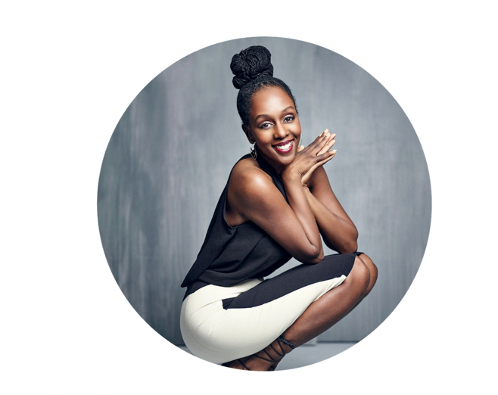

Born a congenital amputee, Los Angeles-based Stephanie Thomas has redefined the contours of fashion styling, putting together accessible looks as a disability fashion stylist and advocate. In 1992, out of necessity, began researching and following clothing trends for people with disabilities. She had no intention of starting a business, she simply wanted to find solutions for challenges related to dressing with disabilities. The problem was there weren’t any - and it was that realization that started her on her now 30-year journey of educating the public on ableism in the fashion industry and working to change it. Thomas is the founder of Cur8able, a disability fashion and lifestyle blog-turned-company, pulling together disability-friendly clothing, disseminating advice and offering discount lists. Today, Stephanie helps executives, leaders, and academics better reach and serve people with disabilities through her work as a speaker, author, stylist, and lobbyist.