Karen Swanson
Biography for Presentations
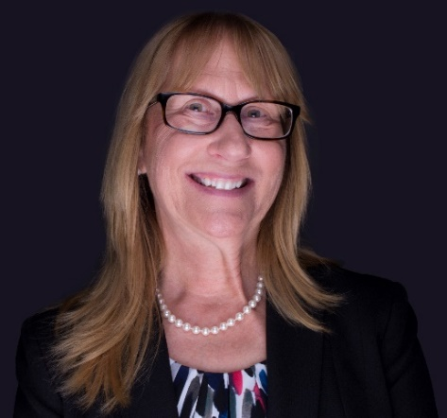
Karen moved with her family to California from New Jersey in 1999. Having had a successful career working 20+ years in the Healthcare field, Karen spent the next 12 years raising their children and volunteering with various local organizations such as band boosters, Little League, Boy Scouts of America, and School Site Council.
Missing the camaraderie and stimulation of working outside the home, Karen joined the Department of Rehabilitation team in 2012. Karen started with Blind Field Services as a Support Services Assistant and promoted to Business Specialist for the Thousand Oaks office in 2015. Working with people with disabilities and assisting them with their employment goals was extremely rewarding! Karen promoted in 2019 to Regional Business Specialist for the Santa Barbara District, supporting this district and staff with their 6 offices in Ventura, Santa Barbara, and San Luis Obispo counties.
In December 2022, Karen joined the Workforce Development Section based in Sacramento as a Business Engagement Consultant. The opportunity to assist businesses diversify their workforce is one of the keys to new perspectives, increased profits, and a wider talent pool. It is this motivation that keeps Karen engaged and driven to help businesses and consumers alike and is passionate about helping our military veterans.
On her free time, Karen enjoys hiking, gardening, book club, going to theater and concerts, rooting for any Chicago sport, and being with family and friends. Karen lives in Ventura County (California is the 6th state she has lived in!) with her husband and husky, Thor.

