The CATESOL San Diego Chapter Invites You to Attend Its 2019 Fall Conference

“GETTING THERE FASTER AND BETTER: ACCELERATING STUDENT LEARNING”
Mr. Colls will share results of a curriculum shift in Cuyamaca College’s ESL program from a “deficit model” philosophy of language teaching to an actual “capacity model” that provides proof that ESL learners are capable of much greater and quicker educational strides than had ever been considered possible.
When:  Time:  Place: | Saturday, November 2, 2019  8:00 am to 1:00 pm  Alliant International University  10455 Pomerado Road  San Diego, CA. 92131 | 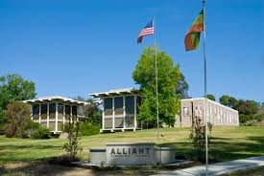
Submit a Proposal (Deadline - September 15, 2019)
https://urlzs.com/KcHSv

Pre-registration is Now Open (closes on Saturday, October 26th)
https://urlzs.com/9o4Ha

Conference Schedule  8-9:00 Registration and Breakfast  9-9:50 Opening Remarks and Plenary  10-10:50 Concurrent Session 1  10-11:30 Vendor’s and Poster Session  11:40-12:30 Concurrent Session 2  12:30-1:00 Prize drawing, Poster Awards and Closing remarks | Online Registration  $35 Member  $25 Student Member  $45 Non-Member  $25 Lead Presenter | Onsite Registration  $45 Member  $35 Student Member  $55 Non-Member

Parking is free for those attending the conference

